Journal 1

Farhana Zahir

25th Oct 2020

In this case of time-independent spot prices, the result shows that the limiting difference between the forward and futures prices...

Please finish the sentence above. Also, please provide a quick review of the journal if you agree with their strategy.

In this case of time-independent spot prices, the result shows that the limiting difference between the forward and futures prices is a function of the eigenvectors of the state price matrix, and that for most relevant cases these differences are small.1

The paper states that empirical research seems to give contradictory answers as to whether forward and futures prices in fact are significantly different, but this research has been hampered by limited sample size, its dependence on constructed forward prices, and the specificity of the time periods covered. The limited sample size may be because forwards are over the counter and a lot of databases are not accessible.

The authors in the journal extend the BP (Beninga and Protopapadakis)2 results by proving a result about the limiting difference’ between forward and futures prices. They show that this limiting difference is a function of the eigenvectors of the state price matrix. They further show that for most relevant cases these differences are always small. The Lucas Consumption model has been used, and the state price matrix has been used to derive both forward and futures prices. Since the research is focused on interest rate-based futures, the term structure is considered time independent and that makes sense. The spot prices of the assets underlying these contracts are determined by the term structure; when the term structure distribution is time-independent (as it is in the Lucas model), the distribution of these spot prices will, as a result, also be time-independent. For this case of time-independent spot prices, the research shows that the limiting difference between the forward and futures prices is a function of the eigenvectors of the state price matrix, and that for most relevant cases these differences are small.

Can this result have a practical use? I guess, not so much. First, the conquest to increase sample size by simulating forward and futures prices, gives rise to ‘male believe’ prices with less connection to the practical world. We all know that futures are more liquid and have less counterparty risk. Forwards can incur high transaction costs because intermediaries are almost always involved in structuring the deals. The deal sizes are bigger and the counterparty risk higher. If we consider transactions costs, liquidity, and counterparty risk, the prices of forwards and futures on similar underlying and same maturity are supposed to differ. The paper has probably simulated forward prices based on the deal sizes of the futures, for which the data is available. That is not an apple to apple comparison in my opinion.

What does other empirical research say about this relationship? A doctoral thesis paper by Andrei Shynkevich3 sheds some light. In the first part, he conducts an empirical investigation of the size and nature of the Eurodollar Futures-Forward differential. They found a positive relationship between the size of the price differential and the time to maturity. The author concludes that average differentials are too small compared to the theoretical predictions and do not increase significantly with longer time to expiration while also on too many occasions the rate differential has a negative sign. This is not very different from the findings of the paper we are analyzing, but we should keep in mind that paper does not account for differences due to mark to market and default risk.

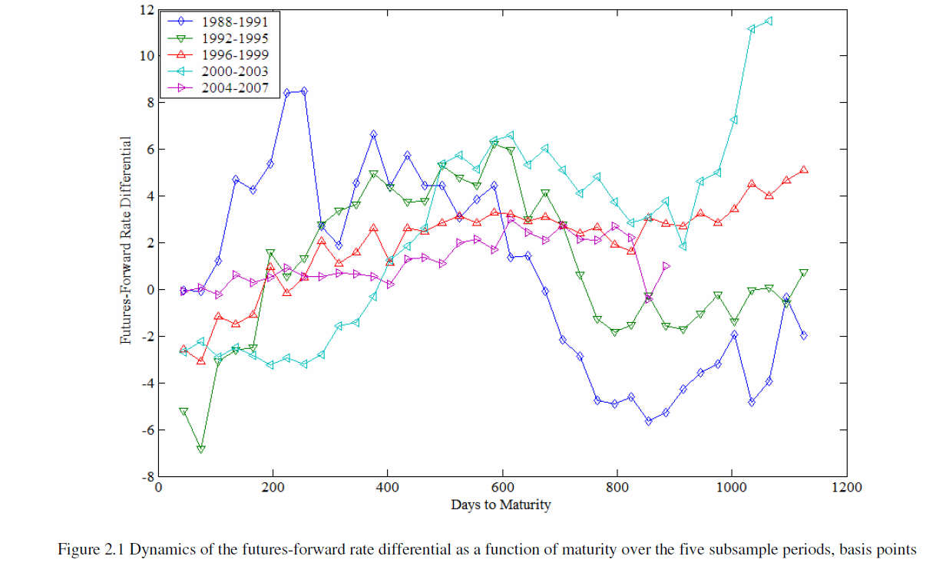

How about the price differential with underlying other than interest rates? Park and Chen4 have tested the hypothesis that if an asset is a hedge against the price fluctuations of the default free discount bond, futures prices will be greater than forward prices due to the continual resettlement specified in the futures contracts. The paper looks at empirical data for four foreign currencies and six physical commodities. The causal relation is that if the covariance between the unexpected change in the price of a commodity and unexpected change in the price of a default free discount bond is less than the variance of the bond, then the futures price of the commodity will be greater than the forward price. The authors found significant positive differences between futures and forward price for gold, silver, silver coins, platinum, and copper.

In conclusion, there is scope for a lot more research on this topic, especially with reference to specific underlying assets and bringing into effect the transaction costs and the tax impacts due to mark to market.

*References:*

*1https://www.researchgate.net/publication/4773611_Limiting_differences_between_forward_and_futures_prices_in_a_Lucas_consumption_model*

*2 Benninga, S., Protopapadakis, A., 1994. Forward and futures prices with Markovian interest rate*

*processes. J. Bus. 67, 401–421.*

*3* *https://digitalcommons.lsu.edu/cgi/viewcontent.cgi?article=4569&context=gradschool_dissertations*

*4* *https://www.researchgate.net/publication/4991787_Pricing_of_Forward_and_Futures_Contracts*